Meadows Shake Up!
Active January!
Every day at Meadows we do a shake up for 5-10 minutes. Here is a calendar for January with some ideas you can do each day. You could print this at home and tick off each day, or if you want to send some photos of you doing your ‘Shake ups’, please email them to meadows.yearthree@taw.org.uk
Let’s get active in January!
Try each of these activities with the people you’re with!
Challenge yourself to get as many bronze/silver/golds as you can! Keep track and celebrate your achievements!
Remember it is important to stay active and healthy!
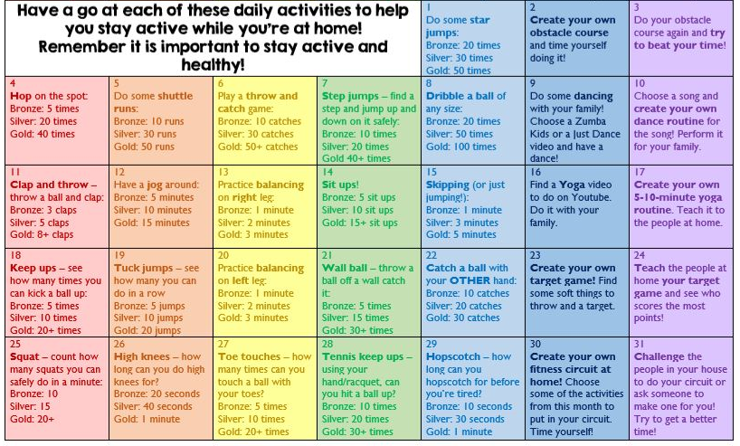

Meadows Shake Up!
Active January!
If you want to keep track of your achievements you can fill in the table below:
4 | 5 | 6 | 7 | 8 | 9 | 10
11 | 12 | 13 | 14 | 15 | 16 | 17
18 | 19 | 20 | 21 | 22 | 23 | 24
25 | 26 | 27 | 28 | 29 | 30 | 31

